Introduction:  
 The objective of the project is to create a material list and price estimator program. The app will allow users to enter a description, quantity, and cost and will provide a total for the list of all the materials. The constraints are that this will be a five-person team and development must be completed on or before October 14th 2023. Due to the expedited nature of the project, development will use the Agile software development life cycle to allow for faster development.  
  
Organization:

Group 1:  
 Barnes, Anthony – Developer, QA Tester, Documentation writer/reviewer  
 Clark, Samuel – Developer, QA Tester, Documentation writer/reviewer

## Requirements:

Developer PC(s),

Visual Studio 2019 Community Edition (or greater)

Programming Language: C#

## Breakdown:

### Planning:

* Review requirements for the assignment
* Once initial loop is complete, address any issues from previous regression

### Design:

* + - Drag label into place for Grand Total
    - Drag buttons into their proper places
    - Drag Data Grid into form and expand to fill area

Develop:

* + - Code a method to multiply the rows of the DataGrid columns
    - Code a method to total the multiplied row data
    - Code a method to export the list as a CSV
    - Code all button events

### Testing:

* Grid allows data entry
* Calculate button works
* Totals are correct mathematically
* Identify any bugs to pass to the next step in SDLC

Feedback:

* + - Receive information from QA testing
    - Forward information back to design team to implement bug fixes
    - Repeat loop as needed until application is complete

### 

## Process Flow Diagram:

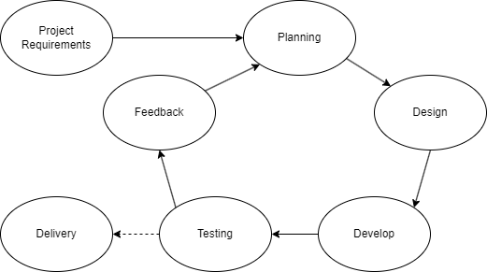

## Project Schedule:

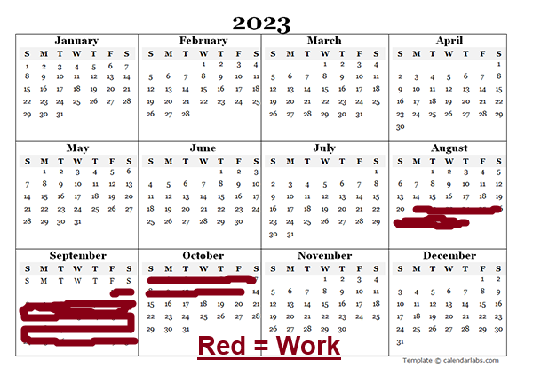

## Monitoring and Reporting Mechanisms:

Communication will take place via IvyLearn’s messaging feature and via email. If necessary, meetings can be scheduled for screenshares to facilitate paired development via Zoom or Microsoft Teams. Code can be stored locally since the codebase is small, however it may be beneficial to move codebase to some kind of source control like GitHub to aid in speed of development and prevent unrecoverable issues.

## Appendix

|  |  |  |  |
| --- | --- | --- | --- |
| Activity | Description | Duration | Dependencies |
| 1 | Documentation | 1 week | None |
| 2 | Drag in planned design elements | 1 day | None |
| 3 | Code MultiplyColumns method | 1 day | 2 |
| 4 | Code AddTotal method | 1 day | 2 |
| 5 | Code Save method | 1 day | 2 |
| 6 | Code Save button event | 1 day | 2, 5 |
| 7 | Code Calculate button event | 1 day | 2, 3, 4 |
| 8 | Code Clear button event | 1 day | 2 |
| 9 | Code cell validation logic | 1 day | 2 |
| 10 | Quality Assurance Testing | As Needed | 2, 3, 4, 5, 6, 7, 8, 9 |
| 11 | Code Subtotals for each line item | 1 day | 2 |
|  |  |  |  |
|  |  |  |  |
|  |  |  |  |
|  |  |  |  |